Project1 - milestone1

## KekeWu – Mobile Design for Bipolar Disorder

# 01 — Project Goals

## Objectives

Design an app for people with bipolar disorder to help themselves and their families, friends track their daily activities and mood change so that healthcare providers can get more detailed insight into their daily highs and lows.

## 02 — Inspirations

1. Create a reliable and stable mobile tool that conducts a more cohesive analysis of users’ daily feelings so they know when and why the stress levels rise or drop.
2. Build an online community that give users and their family members access to monitor and improve the conditions together.

# 03 — General

## Positioning

The Bipolar Disorder App (Name TBD) is the only bipolar disorder mobile app that

provides people with bipolar disorder and their close family members with reliable,

comfortable, collaborative daily mood tracker, and gamification, pleasant experience

through utilizing portable mobile app.

## Mission

Aimed at providing a reference for the professional healthcare providers to help track

the daily highs and lows spirits of patients with bipolar disorder, and hopefully help

analyze how these ups and downs come up.

## Vision

Help people with bipolar disorder live a better, regular and comfortable life.

## Target Audience

Genders: All

Ages: All

Primary

* People with bipolar disorder
  + Have intensive highs and lows during a day
  + Get deeply affected by unstable emotions and would like to get treatment
  + Fed up with ordinary mood track apps and want more funny ways
* People who are relatives or close friends of those who are bipolar disorder
  + Care about their families or friends and want to give them a hand
  + Lack professional medical knowledge but are willing to help with daily record

Secondary

* People who are not sure whether they have bipolar disorder
  + Suffered from unstable emotion changes and mental problems
  + Want to record their mood changes to help with diagnosis
  + Curious and interested about bipolar disorder
* Healthcare Providers who need a tool to track their patients’ conditions
  + Cannot stay with the patients all the time
  + Want to get a better view of the patients’ mood changes.

# 04 — Related Works

**Current Apps**

Similar apps have focused on either monitoring multiple dimensions of human

behavior through a set of sensors or recording users’ mental state related data

by allowing self-reporting.

Specifically, *Bipolar Disorder Guide* is a pure text based app that offers

information on the overview, symptoms & types, treatment & prevention,

living & support for BD. *Moodtrack,* *Better Mood*, *MoodLog* and *Mood* allow

users to record their daily mood changes with short notes. *Daylio, Better Mood*

offer some default daily activities for users’ choices instead of requiring them

typing on their own. *Stigma* goes one step further by creating an anonymous

community for people with similar problems communicating with each other. By

clicking on “request” of one’s post, you will make a request to be his or her pen

pal in real life.

**My App**

Assessing the activities of daily living is very often emphasized as an important

aspect in order to understand progress of bipolar disorder. So mood tracking

will still be the focus of my app, and daily activities will be subdivided into

detailed and common items, like brushing teeth, eating breakfast, feeding the

dog etc. These tasks will be displayed through a gameful way. Also, people

have bipolar disorder tend to have unstable mood states and they may cheat

on their records when in different moods. To fix this, multiple users will have

access to the record of a patient on different devices, they can have more

interactions and contribute together to an accurate every day record.

# 05 — Potential Resources

**Activities**

Will be chosen based on the survey and interview from people with bipolar

disorder.

**User Interface**

Will be designed and produced by myself in Photoshop, Illustrator or any

other possible software.

**Multiuser Editing**

Will be achieved by allowing users to get connected with each other within the

app or to log in with the same account.

# 06 — Tone Words

## Uplifting

Reliable, Comfortable, Private, Objective, Helpful

## Functional

Tracker, Monitor, Listener, Recorder, Diary

## Available

Portable, Mobile, Fun, Creative, Gameful

# 07 — Digital Prototype

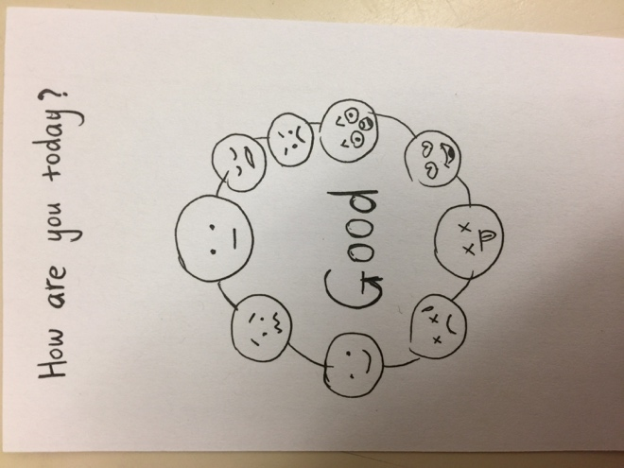

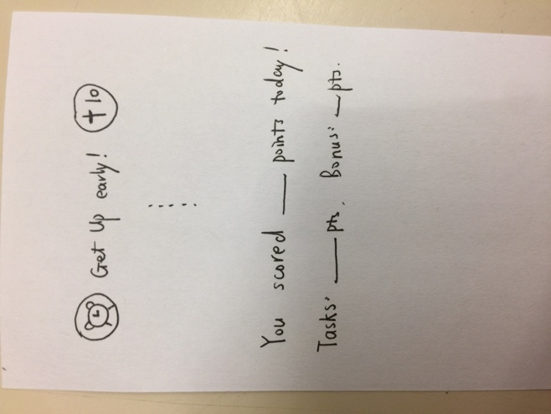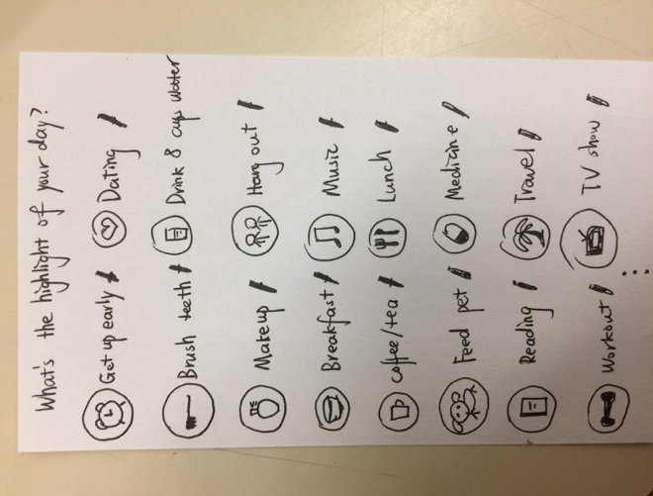

On the first screen, uses need to choose from nine basic human emotional icons to describe his or her day. On the second screen, users can record their daily life by tapping one of the default activities or add their own. Clicking on the pencil icon, users can take a note for a specific activity. Besides, other users (family members, close friends, etc) could also help add or modify items on this screen. Each activity has a different score. At the end of each day, the user will get a total score for the day, which is consisted of his or her own points and bonus from other users.